**Sub-System-specification-Document**

**Net1Bier**

**By:**

**FJ Fourie 26047799**

**Design 2017**

Supervisor: Prof J. Holm

Potchefstroom

2017

**Contents**

4.3.1 Sub-system functional Analysis 1

4.3.2 Sub-system Interface Definitions 3

**List of Figures:**

Figure 1: Interface of sub system 1

Figure 2: Functional analysis of sub system 2

**List of Tables:**

Table 1: Sub-System interface definitions 3

### 4.3.1 Sub-system functional Analysis

Below in Figure 1 the interface sub system is shown, for the complete interface overview see team design portfolio. Below there is also the Functional analysis of the sub system shown in Figure 2.

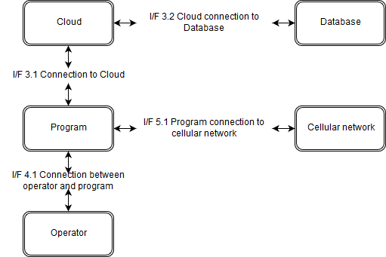

Figure 1: Interface of sub system

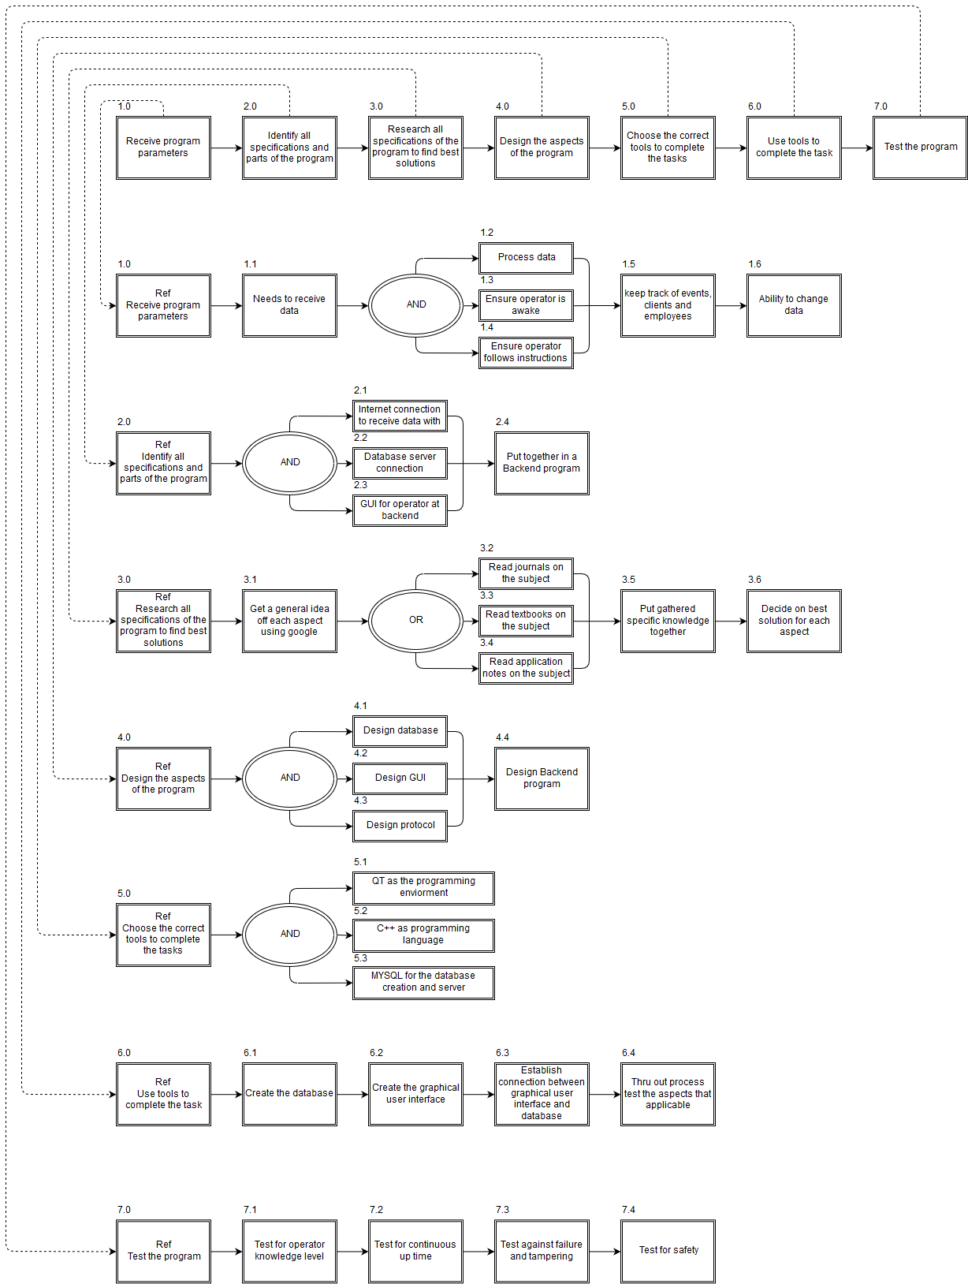

Figure 2: Functional analysis of sub system

### 4.3.2 Sub-system Interface Definitions

Table 1: Sub-System interface definitions

|  |  |  |
| --- | --- | --- |
| **Interface** | **Type** | **Define** |
| I/F 3.1 | Computer | This is the interface between the backend program and the clod server |
| I/F 3.2 | Computer | This is the interface between the cloud server and the database |
| I/F 4.1 | Electronic/Computer | This is the interface between the backend program the operator |
| I/F 5.1 | Electronic/Computer | This is the interface between the back-end program and the cellular network. |
| I/F 2 | System/PC | Network connection between system and PC |